# Workshop: Console Connect Four

We will create a simple two-player "Connect Four" game in this workshop. Here is how the game is going to look in the end:

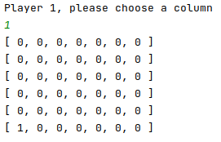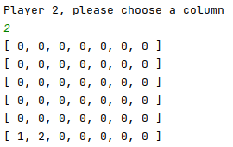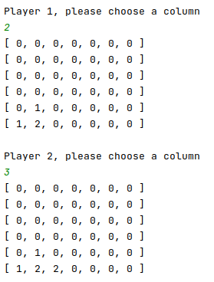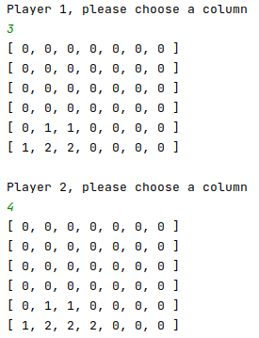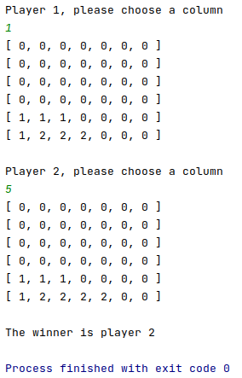

## The Main Logic

* A player wins when he/she connects four slots.
* The winning connected slots must be consecutive
* A connection can be
  + Horizontal
  + Vertical
  + Diagonal

## BONUS

* Try writing validation logic for:
  + More than one player
  + Reset logic
* Try adding error messages for invalid column